PET SHOP

The pet shop database has 3 main collections: shop, pets and customers. The pets collection contains pet details like name, age, gender, price, species, breed and adopted(Boolean) . The customers collections has the following fields: name, phone, email and id of pet adopted. The shop collection contains some shop details like name, address, phone, email as well as two arrays, pets and customers which contains id of the pets and customers respectively, for lookup.

PETS CREATION

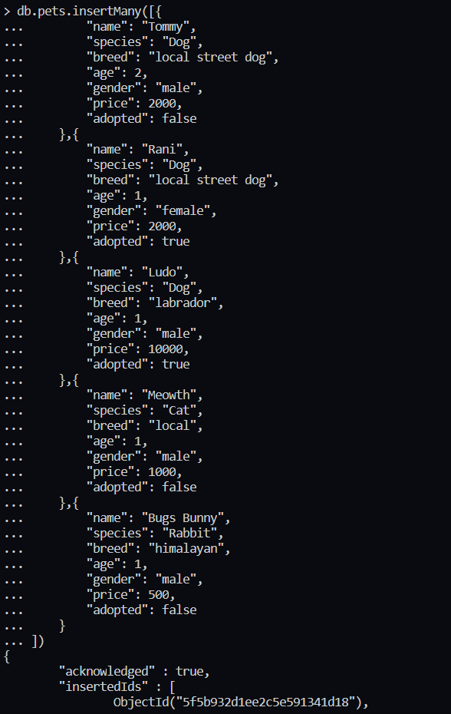

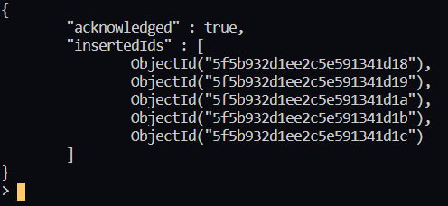

SHOP CREATION

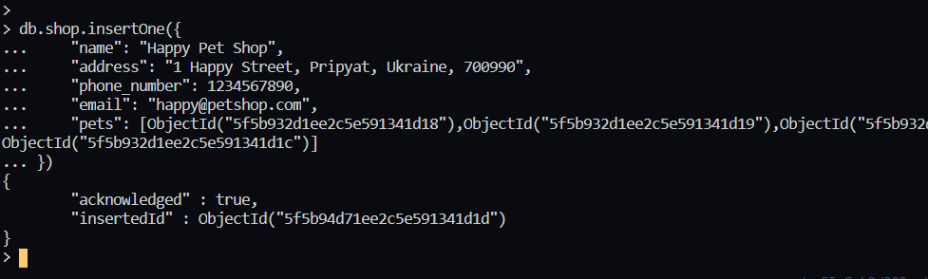

CUSTOMERS

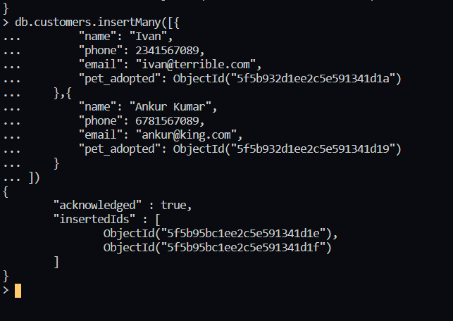

UPDATING shop to include customer data

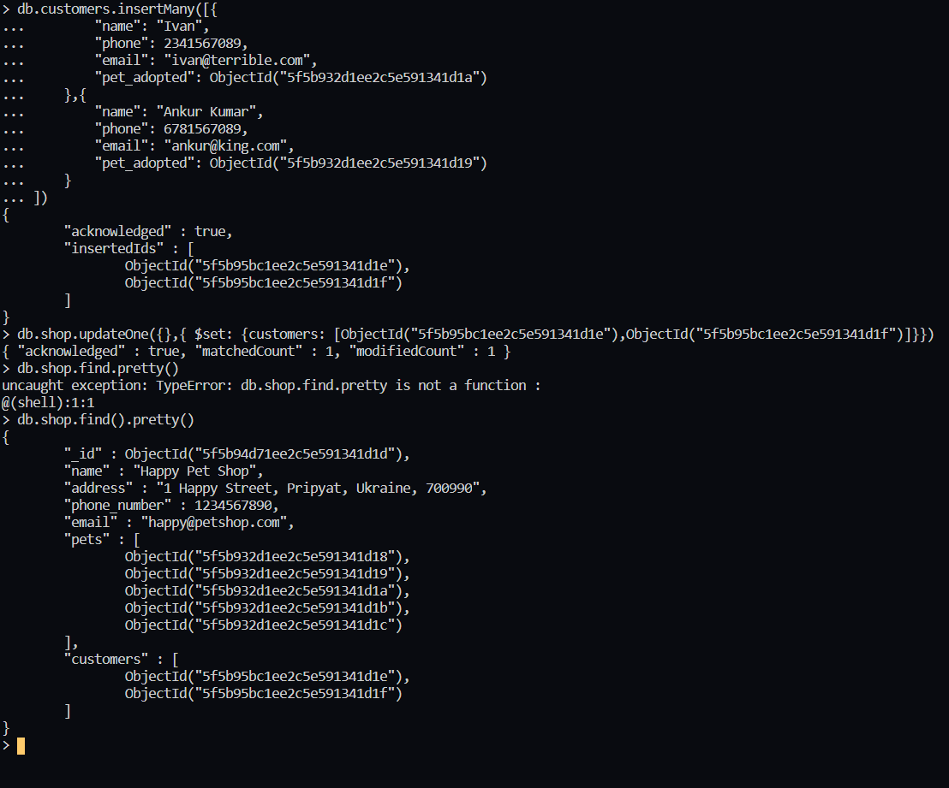

Querying Customer Details With Shop Data

